Name________________________________________________ Date____________ Section_____________
Absolute Location
Obj: By the end of class you will be able to describe the absolute location of places.
LG: Describe a place’s absolute and relative location.

Absolute location is the ________________________________ of a place. We use ____________________________
_______________________________ to find the exact location.

Latitude and longitude lines divide the world into a ________________. Every place in the world has a unique location because of this grid.

Latitude lines are __________________ (across)—like a______________________. They are measured ____________ and ______________.
Longitude lines are ________________(up and down)—like a _________________________. They are measured

Guided Practice:

The base latitude line is the _______________. The ____________________ is 0⁰. If a latitude is above it, it is measured _______________. If a latitude line is below it, it is measured ________________.

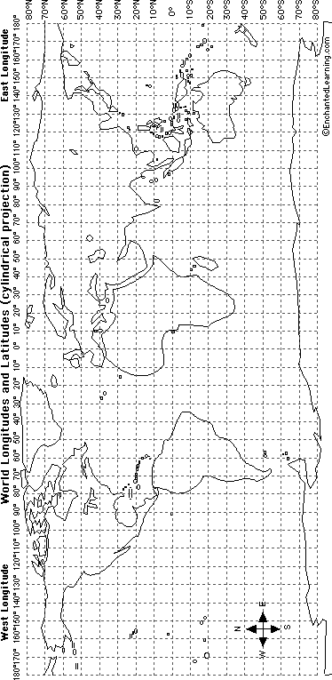
The base longitude line is the _______________________. The _____________________________ is 0⁰. If a longitude line is left of it, it is measured ______________. If a longitude line is right of it, it is measured _________________.

We find latitude first. Then longitude. We always have to include the directions.

Find 40⁰N, 70⁰W. Draw an * Write the coordinates of the letter Z _____________________________
A

Find 35º S, 157⁰E. Draw an X Write the coordinates of the letter S _____________________________

Use the map on the front of the page:

Find 11⁰N, 134⁰E, Write the Letter A
Find 79⁰S, 26⁰E. Write the letter B
Find 42⁰S, 123⁰W. Write the letter C
Find 53⁰N, 32⁰W. Write the letter D
Independent Practice / Homework :
1. Draw a red line along the equator (0 degrees latitude).
2. Draw a purple line along the Prime Meridian (0 degrees longitude).
3. In which ocean is the location 10 degrees S latitude, 75 degrees E longitude located? Mark it on the map with a "X" and write the name of the ocean.
4. In which ocean is the location 30 degrees N latitude, 60 degrees W longitude located? Mark it on the map with a "Y" and write the name of the ocean.
5. Mark the following cities on the map:
C. Cairo: 30°N, 31°E MC. Mexico City: 19°N, 99°W
MO. Moscow: 55°N, 37°E MU. Mumbai: 19°N, 72°E
NA. Nairobi: 1°S, 37°E NO. New Orleans: 30°N, 90°W
NY. New York: 40°N, 74°W R, Rio de Janeiro: 23°S, 43°W
SE. Seattle: 47°N, 122°W SY. Sydney: 34°S, 151°E
TK. Tokyo: 35°N, 139°E T. Toronto: 43°N, 79°W
CT. Cape Town: 34°S, 18°E
H. Hong Kong: 22°N, 114°E
J. Jakarta: 6°S, 106°E
LA. Los Angeles: 34°N, 118°W
LI. Lima: 12°S, 77°W
LO. London: 51°N, 0°W
MC. Mexico City: 19°N, 99°W
MO. Moscow: 55°N, 37°E
MU. Mumbai: 19°N, 72°E
NA. Nairobi: 1°S, 37°E
NO. New Orleans: 30°N, 90°W
NY. New York: 40°N, 74°W
R, Rio de Janeiro: 23°S, 43°W
SE. Seattle: 47°N, 122°W
SY. Sydney: 34°S, 151°E
TK. Tokyo: 35°N, 139°E
T. Toronto: 43°N, 79°W

