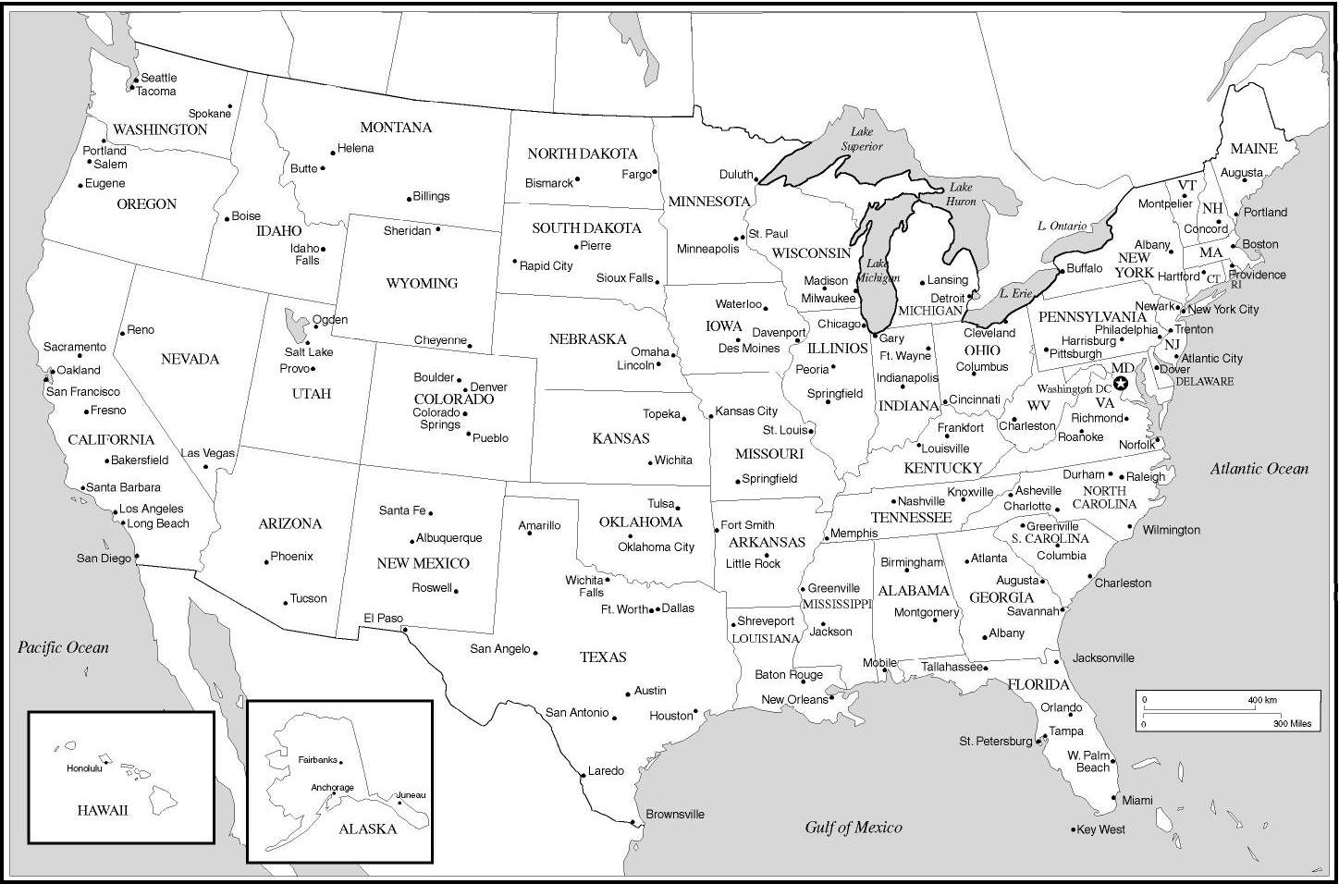
- Chicago to St. Louis: __________ 4. Minneapolis to Tampa: ________ 7. Washington D.C to Indianapolis: _________
- San Diego to Nashville:_________ 5. Phoenix to Roswell: _________ 8. Las Vegas to Denver: _________
- Houston to Kansas City:__________ 6. Memphis to Little Rock:_________ 9. Atlanta to Jackson: _________

