Name____________________________________________ Date________________ Section__________
Relative Location
Obj: By the end of class you will be able to define absolute and relative location and describe the relative location of places.
LG: Describe a place’s absolute and relative location.

What is absolute location? | Relative location—_________________________________________________________  ___________________________________________________________________________  ___________________________________________________________________________  Absolute location—__________________________________________________________  ___________________________________________________________________________  ___________________________________________________________________________

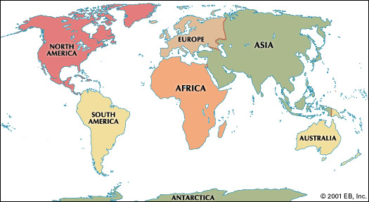
1. Describe the relative location of Asia.

2. Describe the relative location of Africa

3. Describe the relative location of Australia

4. Describe the relative location of North America

5. Describe the relative location of Europe

6. Describe the relative location of Antarctica.

7. Describe the relative location of South America.

Independent Practice:
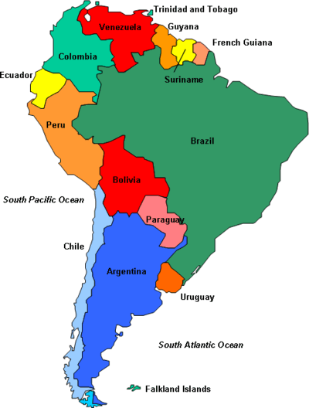
Describe the relative location of Brazil. ____________________________________________________________________________________________________________
Describe the relative location of Peru. ______________________________________________________
______________________________________________________
Describe the relative location of Bolivia. ______________________________________________________
____________________________________________
Describe the relative location of Argentina._____________________________________________
__________________________________________________________________________________________________
EXTRA PRACTICE:
USE A MAP OF THE UNITED STATES TO ANSWER THE FOLLOWING QUESTIONS:

1. Describe the relative location of Texas.

2. Describe the relative location of Missouri.

3. Describe the relative location of Alabama.

4. Describe the relative location of California.

5. Describe the relative location of New York.
6. Describe the relative location of Illinois.

7. Describe the relative location of Colorado.

8. Describe the relative location of Pennsylvania.

9. Describe the relative location of Georgia.

10. Describe the relative location of Florida

